Gay Brewer, Jr. Fund
2018 Grant Application
A Kentucky Golf Foundation Program

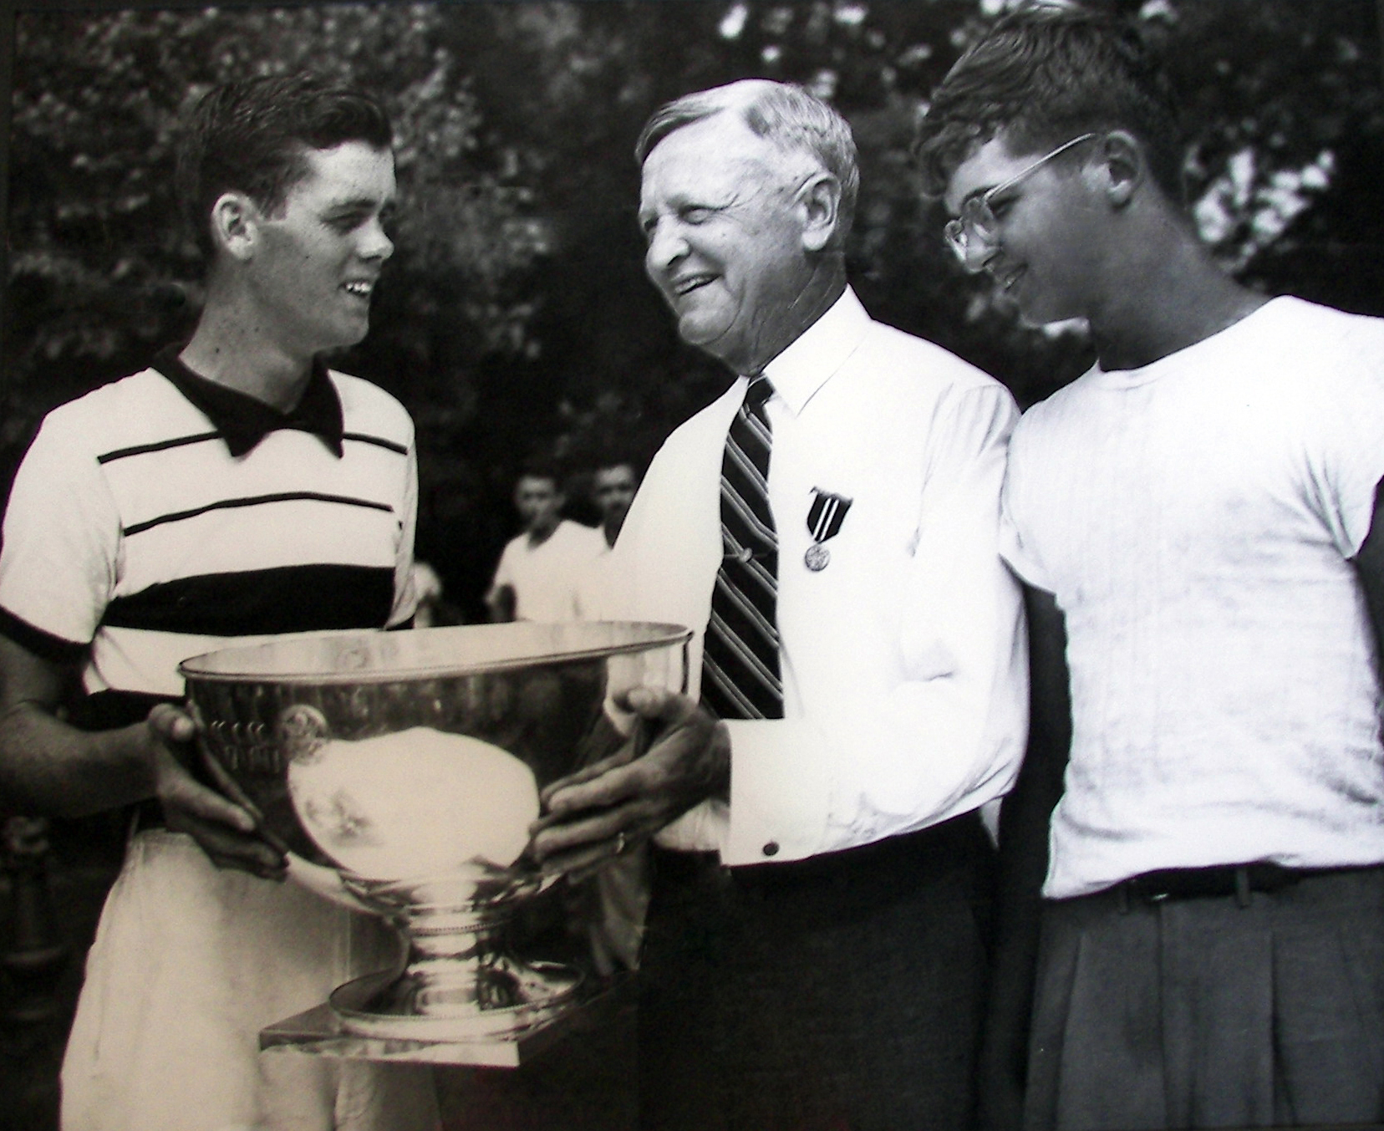

Gay Brewer’s incredible career began with numerous junior golf titles, including three consecutive Kentucky High School Golf Boys Championships from 1949-1951, a feat which has never been equaled. He won the 1949 United States Junior Championship at Congressional Country Club, and remains the only Kentuckian to capture this prestigious title. As an amateur, he captured the 1951 Kentucky Open Championship along with Kentucky State Amateur Championship titles in 1952 and 1953 and the Southern Amateur Championship in 1952. His PGA Tour career included eleven victories, highlighted by the 1967 Masters. He represented the United States on victorious Ryder Cup teams in 1967 and 1973. Gay Brewer, Jr. was inducted into the Kentucky Golf Hall of Fame in 1989.

He learned the game at Picadome Golf Course in Lexington, a course, which now bears his name – the Gay Brewer, Jr. Golf Course at Picadome.

Mr. Brewer passed away on August 31, 2007, and to honor his legacy, family and friends established the Gay Brewer, Jr. Fund to assist junior golfers in Kentucky with the ability to compete at the regional and national level with the hope to help them gain exposure to earn a college scholarship.


Gay Brewer, Jr. Fund
Grant Application

The purpose of the Gay Brewer, Jr. Fund is to provide financial assistance to Kentucky junior golfers who have demonstrated the ability to complete in junior golf competitions at the regional and national level. It is the hope that by being able to play in such competitions, the junior increases their ability to earn a college scholarship.

ELIGIBILITY & GUIDELINES:

To be eligible, applicants must

- Be at least 15 years of age and not have graduated from high school

- Be a resident of the Commonwealth of Kentucky

- Has not yet received a college scholarship

- Complete Part I, Part II and III of Grant Application

- Provide Performance Record to include results and scoring details

- Provide a tentative 2018 tournament schedule

Important Information

- Grant Applications will be accepted until midnight (EDT) on Friday, May 4, 2018

- Selection of Grant recipients will be announced by May 31

- Applicants will be evaluated by the Gay Brewer, Jr. Grant Committee based on past performance in golf competitions, financial need and essay response

- Multiple grants in the amount of up to $3,000 (typically award is $1,500) are awarded annually

- The Gay Brewer, Jr. Grant Committee reserves the right to withhold funding for a grant recipient in certain circumstances, such as unbecoming conduct and withdrawing from an event without a valid reason

- Grants may be used for up to six events that are limited exclusively to junior golfer’s exclusive competitions, with a maximum of $1,000 per event. Competitions should be recognized as prominent regional or national events

- In accordance with the Rules of Amateur Status, a grant may cover expenses associated with competing in an event limited exclusively to junior golfers (transportation and travel costs, accommodations and lodging, meals and refreshments, entry fees, caddie fees, cart fees, and practice round fees), and the recipient will receive re-imbursement for such expenses after proper documentation (receipts) have been submitted

Examples of eligible expenses:

  - Costs incurred when traveling to and from an event. This may include gas, airfare (junior golfer only), airport transportation, rental cars and cabs

  - Reasonable food and beverage costs (junior golfer only) incurred while attending an event

  - Hotel costs incurred while attending an event (junior only, unless sharing room with parent or guardian)

  - Tournament entry fees

  - Cart or caddie fees

  - Practice round fees

Examples of ineligible expenses:

- Airfare for parent or guardian

- Food and beverage costs for parent or guardian

- Golf equipment
PART I - APPLICANT INFORMATION

Full Name:________________________________________________________________________________

Address:__________________________________________________________________________________

City:_________________________________________ State: ______ Zip:____________________

Date of Birth: _________________________________

High School: ______________________________________________________________________________

Currently, I am a high school: _____ Freshman _____Sophomore _____Junior _____Senior

Parent Phone #:__________________________________________________________

Applicant Email:_________________________________________________________

Parent/Guardian’s Email:__________________________________________________

PART II – APPLICANT ESSAY
- Please explain why you feel as though you deserve to be awarded a Gay Brewer, Jr. Grant
- Essay must be typed and double spaced
- Essay should be no more than two pages

PART III – PERFORMANCE RECORD
- Please provide your performance record for at least the last two years
- Record should include scores in addition final results
- Performance Record must be typed

PART IV – PARENT OR GUARDIAN NARRATIVE
- Please provide a short narrative why applicant deserves to be awarded a Gay Brewer, Jr. Grant
- Financial need is an important factor in determining recipients, thus include financial need in narrative

SUBMISSION
Return Application by mail with Part II, III and IV to:

Kentucky Golf Foundation
Attention: Gay Brewer, Jr. Grant
1116 Elmore Just Drive
Louisville, Kentucky 40245

OR by email to:

Connie Saner
csaner@kygolf.org

Applications must be received at Golf House Kentucky
by 4 pm on May 4, 2018

