Justin Thomas Fund
2018 Grant Application
A Kentucky Golf Foundation Program



​ Justin starting playing golf at the age of two and was competing in tournaments by the age of eight, winning his first tournament that June in the 12 and under division. Justin has won 125 individual events on the local, national, and international stage, and additionally has been a part of many victorious teams’ squads. One of the top players in the Polo Junior rankings and a Polo All American in 2010, Justin went to high school at St. Xavier High School in Louisville, winning the state high school championship both individually and twice as a team. He was named Mr. Golf in Kentucky in 2009. In 2010, Justin won the Terra Cotta Invitational, with a final round 66, his first major amateur win. That summer he was runner-up at the US Junior Amateur and in 2011, Justin won the International Junior Byron Nelson Award.

Justin continued his golf at the University of Alabama where he won the first college event he played in, The Carpet Classic, firing a 30 on his final nine. In addition to winning the prestigious Jones Cup Invitational, one of the top prizes in amateur golf, Justin won six events as an individual. As a freshman, Justin won the Haskins Award and the Jack Nicklaus Award, as the national NCAA Division 1 player of the year, and the Phil Mickelson Award as the freshman player of the year. A SEC Champion as an individual and twice a member of the Alabama team in 2012 & 2013, Justin was also named SEC Player of the Year in 2012. A semifinalist in the 2012 US Amateur, he has also been a member of a AJGA Canon Cup team, two Palmer Cup teams, a Junior Ryder Cup team, the USGA World Amateur team in 2012, and a member of the winning 2013 NCAA Championship and Walker Cup teams. Justin turned professional in 2013 and has since climbed to 2nd in the World Golf Rankings, has won 8 times on the PGA Tour including the 2017 PGA Championship, and became a member of the exclusive 59 club in the first round of the 2017 Sony Open in Hawaii. ​

In his rookie season on the PGA Tour, Justin hit a hole-in-one at the Greenbrier Classic. For his hole-in-one, Justin was awarded monies to be given to charities of his choice. Knowing the sacrifices parents make for their junior golfers to play national events, Justin decided to work with the Kentucky Golf Foundation to establish the Justin Thomas Fund to provide Kentucky junior golfers whose skill level demonstrates they have the potential to play at the collegiate level enabling them to play a more robust national junior schedule with the goal to gain more exposure and earn a college golf scholarship.



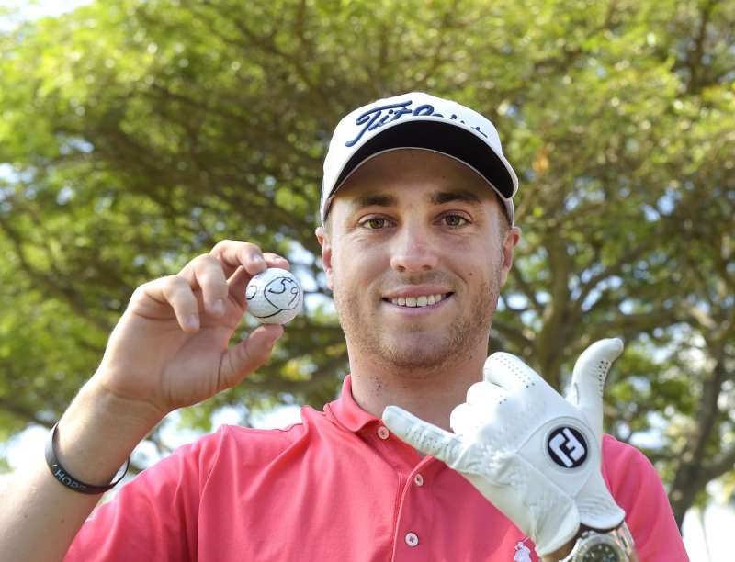





Justin Thomas Fund
Grant Application

The purpose of the Justin Thomas Fund is to provide financial assistance to a Kentucky junior golfer whose past performance record demonstrates they have the potential to play at the collegiate level enabling them to play a more robust national junior schedule with the goal to gain more exposure and earn a college golf scholarship.

ELIGIBILITY & GUIDELINES:

To be eligible, applicants must

- Be at least 14 years of age and not have graduated from high school

- Be a resident of the Commonwealth of Kentucky

- Has not yet received a college scholarship

- Complete Part I, Part II and III of Grant Application

- Provide Performance Record to include results and scoring details

- Provide tentative 2018 schedule for summer tournaments

Important Information

- Grant Applications will be accepted until 4 p.m. (EDT) on Friday, May 4, 2018

- Selection of Grant recipients will be announced by May 31

- Applicants will be evaluated by the Justin Thomas Grant Committee based on past performance in golf competitions and essay response

- Total grant of $5,000, which may be split amongst individuals on a need basis

- The Justin Thomas Grant Committee reserves the right to withhold funding for a grant recipient in certain circumstances, such as unbecoming conduct and withdrawing from an event without a valid reason

- In accordance with the Rules of Amateur Status, a grant may cover expenses associated with competing in an event limited exclusively to junior golfers (transportation and travel costs, accommodations and lodging, meals and refreshments, entry fees, caddie fees, cart fees, and practice round fees), and the recipient will receive re-imbursement for such expenses after proper documentation (receipts) have been submitted

Examples of eligible expenses:

  - Costs incurred when traveling to and from an event. This may include gas, airfare (junior golfer only), airport transportation, rental cars and cabs

  - Reasonable food and beverage costs (junior golfer only) incurred while attending an event

  - Hotel costs incurred while attending an event (junior only, unless sharing room with parent or guardian)

  - Tournament entry fees

  - Cart or caddie fees

  - Practice round fees

Examples of ineligible expenses:

- Airfare for parent or guardian

- Food and beverage costs for parent or guardian

- Golf equipment
PART I - APPLICANT INFORMATION

Full Name:________________________________________________________________________________

Address:__________________________________________________________________________________

City:_________________________________________ State: ______ Zip:____________________

Date of Birth: _________________________________

High School: ______________________________________________________________________________

Currently, I am a high school: _____ Freshman _____Sophomore _____Junior _____Senior

Parent Phone #:__________________________________________________________

Applicant Email:_________________________________________________________

Parent/Guardian’s Email:__________________________________________________

PART II – APPLICANT ESSAY
- Please explain why you feel as though you deserve to be awarded a Justin Thomas Grant
- Essay must be typed and double spaced
- Essay should be no more than two pages

PART III – PERFORMANCE RECORD
- Please provide your performance record for at least the last two years
- Record should include scores in addition final results
- Performance Record must be typed

SUBMITION
Return Application by mail with Part II, III to:

Kentucky Golf Foundation
Attention: Justin Thomas Grant
1116 Elmore Just Drive
Louisville, Kentucky 40245

OR by email to:

Connie Saner
csaner@kygolf.org

Applications must be received at Golf House Kentucky
by 4 p.m. on May 4, 2018

